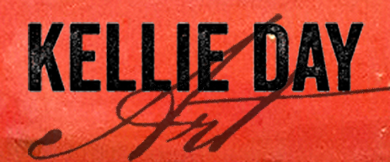

*This course is about establishing a creative business and a life you love.*

31 Email Ideas

**When you’re NOT promoting something for sale, here are some ideas for Emails you can write to your fans…** Keep it simple, and valuable to your readers.

1. What’s going on in your studio
2. Your paintings in process
3. A photo or story about YOU – out in your life, getting inspired – on a walk or coffee shop, or art journaling
4. Studies you are doing
5. Color palettes you’re exploring
6. Close up photos of things that inspire you – botanicals, colors, landscapes, birds,
7. Tell a quick story of something that just happened– a trip, a class, an encounter
8. A favorite Art tool
9. A creative book you like
10. What’s sold recently, or photos of your fans with your paintings in their home
11. A commission you’re working on
12. Another Artist who’s show or studio you visited
13. Ask your fans to help you name a painting
14. Giveaway – some free notecards or a print to the first 10 people who respond with their favorite artist
15. A testimonial – if someone loved your Art, and talked about it or wrote about it, share that story!
16. A downloadable gift – “Thanks for being here, here’s a little something for you”
17. Something you accomplished with your Art – won an award, celebrating getting into a juried show, got into a new shop
18. An inspirational Art quote – especially nice to lay these on top of your art – people love to share these
19. What you’re up to… “Here’s the latest in my Art life I wanted to share with you”
20. Ask your fans a question about what inspires them
21. Talk about your paintings and what they’re about
22. Create a quickie video on your phone, or share an Instagram reel
23. Feature one of your favorite charities to donate a painting to
24. A blog post you’ve written
25. Your most popular Instagram post
26. Talk about a film or Artist documentary and one thing that inspired you
27. What’s a challenge you’re working on? Talk about how are overcoming it
28. Personal stories that are art related – did your family help you hang your show? Did you husband frame your work and you have a photo?
29. Review an Art material you love
30. Feature one of your friend artists, and ask them to feature you to their list
31. Share your Art dreams